# Common

## Users and roles

There are three types of roles in system:

* user – unauthorized client
* customer – authorized client, potential buyer of tokens
* super – representative of the system owner

User can only view statistics and sign in\ sing up in the system. He has the following characteristics:

* Ethereum address
* identifier
* private key ???

Customer can also buy tokens.

Super cannot buy tokens, he should start ICO and change the rate of tokens.

In Fig. 1.1 you can show difference between these roles.

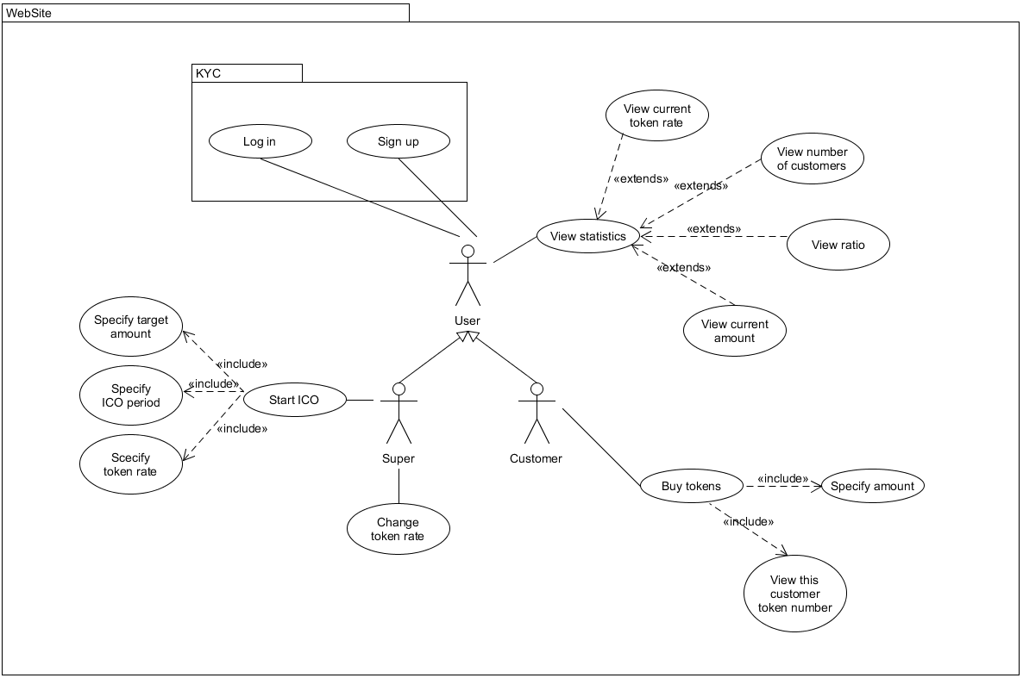

*Figure 1.1. Use case diagram of ICO system*

## Business processes

As you can see in Fig. 1.1 there are some use cases in system. More about them.

### Log in

Role: User

Scenario: implemented by KYC

### Sign up

Role: User

Scenario: implemented by KYC

### View statistic

Role: User, Customer, Super

Scenario:

* user opens the statistics page
* user choses the statistic type

### View current token rate

Role: User, Customer, Super

Scenario:

* user choses the current token rate statistic type
* WebSite calls data from blockchain
* WebSite show current token rate

### View number of customer

Role: User, Customer, Super

Scenario:

* user choses the number of customer statistic type
* WebSite calls data from blockchain
* WebSite show current customers number

### View ratio

Role: User, Customer, Super

Scenario:

* user choses the ratio statistic type
* WebSite calls data from blockchain
* WebSite show current ratio of the sold tokens to the common tokens number

### View current amount

Role: User, Customer, Super

Scenario:

* user choses the current amount statistic type
* WebSite calls data from blockchain
* WebSite show current amount collected by selling tokens

### Buy tokens

Role: Customer

Scenario:

* user opens the selling page
* user specifies amount in ETH for which he wants buy tokens
* user presses OK button
* WebSite sends data to blockchain
* WebSite calls this user token number from blockchain
* user sees his tokens

### Start ICO

Role: Super

Scenario:

* user opens the ICO starting page
* user specifies date, when ICO must start
* user specifies date, when ICO must end
* user specifies the token rate
* user specifies target amount in ETH
* user presses OK button
* WebSite send request to start to blockchain
* blockchain returns result of starting (successful or unsuccessful)
* WebSite shows the result of starting